Template for Bridges Proceedings Paper

Carlo H. Séquin1 and Another Coauthor2 (only use superscripts for multiple authors)

1CS Division, University of California, Berkeley; sequin@cs.berkeley.edu
2Another Famous Institution, Luzern, Switzerland; coauthor@google.com

Abstract
This document serves as a template for the preparation of papers to be published in the refereed Proceedings of the Bridges Conference. It contains detailed formatting instructions as well as some general guidelines for appropriate content of such papers. Adherence to this template is important, since the Proceedings will be composed directly from your manuscripts in their final submitted form. Your abstract should be only one paragraph, comprising anywhere from three to eight lines of text—the shorter the sweeter. Abstracts will be used separately from the rest of the paper; please avoid footnotes, citations, as well as special symbols and formatting.

Some Guide on Content
Let’s start with some advice on the subject matter and content of a Bridges paper, since this should be an author’s first concern. The Bridges Proceedings are considered a refereed journal, and as such we are trying to maintain quality standards that will make its papers count in academic personnel reviews and promotion cases. Thus, most importantly, every paper should present some novel achievements, experiments, artwork, and/or insights by the authors. General reviews or tutorials, cobbled together from various blogs or Wikipedia pages are not appropriate. Also, keep in mind that the number of pages in the Proceedings as well as your presentation time at the conference are limited; so choose a scope for your presentation that fits into these constraints.
Regular papers should be either 8 or 6 pages including references. Every paper should nicely fill an even number of pages without a lot of wasted white space, so that we can make optimal use of the Proceedings pages and start every paper on a right-hand page.
Short papers, which have a later submission deadline, should be 4 or 2 pages long. Here it is particularly important to focus on just one or two novel ideas and results. Short papers are not a good medium to give tutorial introductions or cursory reviews over a domain that could be the subject of one or more books. Also, this is not the place to give preliminary ideas on new teaching experiments, or to present intuitive hunches how some classical artwork might be analyzed in a novel way. A Bridges paper should only be submitted after the experiments or novel analysis have been performed and when concrete results are available.
The program committee has found that certain types of papers almost always need to be rejected: papers on numerology or work that extracts numbers or ratios from artwork or architecture. A somewhat “fuzzy” search for the Golden Ratio (or any other ratio) will almost always produce some hits (a simple matter of statistics). However, such coincidences do not tell us anything about the method or intent of the creator of those artifacts unless there is some other compelling evidence, such as auxiliary lines or notes that explicitly state what the artist or architect was doing.
Please write your paper in such a way that attendees with a general education can follow your discourse without the need to look up several references to find out what the main gist is of your paper. Skip lengthy sections on background and previous work and instead give clear and detailed explanations on your novel contributions, ideally well-supported with diagrams and/or images.

Use of this Template
If you are writing your paper using MS-Word or a compatible word-processor such as OpenOffice [4], please use a copy of this document as your starting point. This template has been set with the proper paper size and all the necessary styles for proper formatting. Just replace segments in this text with your own text; introduce it as pure text and, if necessary, select the appropriate style from the style menu. Also substitute your own image for the figures in this template, either as an individual figure like Figure 1, or, alternatively, as in the composite Figure 2. Images on the same line of a figure should be the same height, as in Figure 2. Try to use as much of the page as possible when inserting images and strive for an attractive page layout. By default, figures are placed in-line with text, starting on a new line, and separated horizontally by a few blank spaces. The line that contains the figure(s) should have its style set to be Figure Display. Each figure is then followed by a paragraph with style Figure Caption.
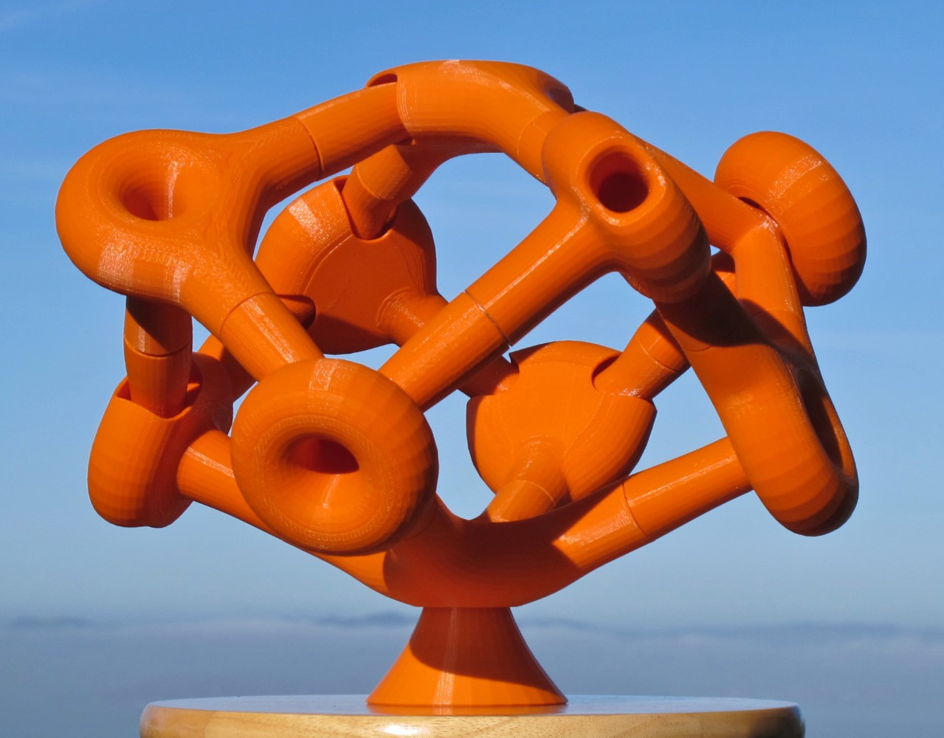
Figure 1: An individual figure [6]. Make it large enough so that necessary details can be seen. Fine-tune its size, so that you obtain convenient page breaks.

Paper Size, Margins, and Styles
The Proceedings will be printed using US Letter size paper (8.5 by 11 inches) as in this document. If you are working outside the USA, please check that you have not used A4 paper, which may be the default in your country. Do not insert page numbers, headers or footers; these will be inserted later at the publishing stage.
This template has the proper margins set. The result should conform to the following specifications: On the first page, the distance from the top edge of the paper to the first line of the title should be 3 cm (1+3/16 inches). To achieve this, we have placed one extra line with font size 16 pt at the top of the title page. On the second and subsequent pages, the distance from the top edge of the paper to the top of the first line of type should be 2.5 cm (1 inch). The widths of the margins on left and right edges and at the bottom of the page should all be 2.5 cm (1 inch) as well. Use one blank line between the end of the paragraph and the next major heading.
The font is Times New Roman. The text of the main body, as well as the figure captions use size 11 pt. Section headings, authors, and affiliations are size 12 pt. Paper title is 16 pt. Abstract is 9 pt. Use this template to see what items are printed in bold face or in italics. When editing your document in MS-Word, make sure you have the Styles Pane open, so that you can readily click and choose the desired style for any piece of text. This panel also contains a small Blank_line (of 8 pt); this comes in handy, when you want to balance the length of a page or insert some extra space between the main text and figures and/or figure captions. Use italics for emphasis, rather than blood face (which reads like yelling.)
The Styles Pane shows two types of paragraphs: Body Text and Body Text 2. Use the first type (which has no indentation) after a section heading. Use the second type (with 0.3” indentation) for all subsequent paragraphs. These styles will justify text to both the left and right margins, which is the correct Bridges style.

Figures and Tables
You must obtain permission and include attribution to use any copyrighted material. Images should be high quality. The proceedings will be produced in full color both online and in print. But be careful that your images do not make your PDF larger than 10 Mb. To insert a figure, just start a fresh line and use the Insert Pictures command to bring in a figure, then re-scale it interactively to a convenient size. You can also copy and paste figures from another document [5]. Set the line style to Figure Display. The figure is then followed by a paragraph with style Figure Caption. You need to enter manually the string “Figure 1:” and then set it to bold and not-italic. We did not use the automatic figure and table numbering system in this template; we found it often to be more trouble than helpful. Add an extra empty line after the Figure Caption. When you refer to a figure use Figure 1, or Figure 1(a). Do not abbreviate Figure.
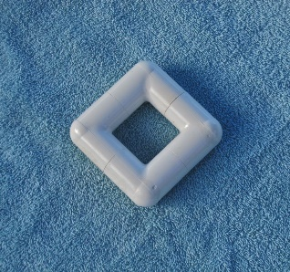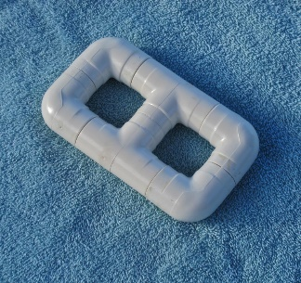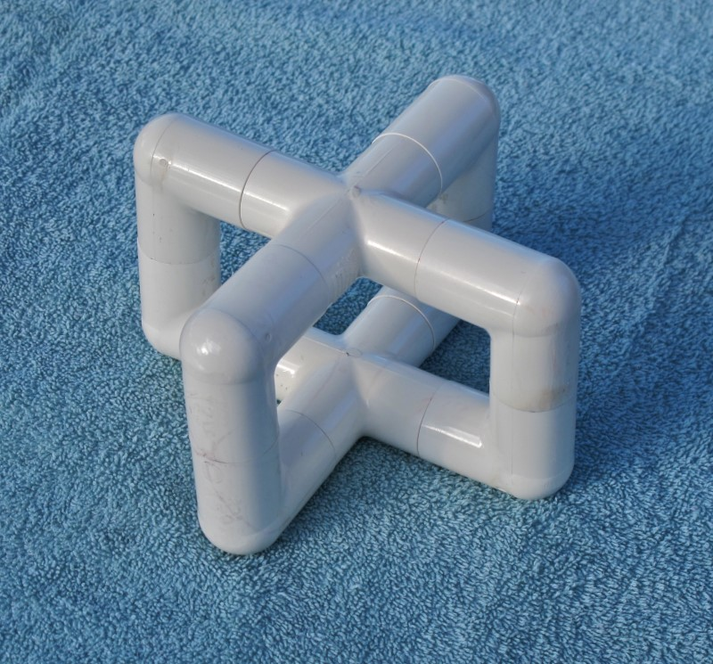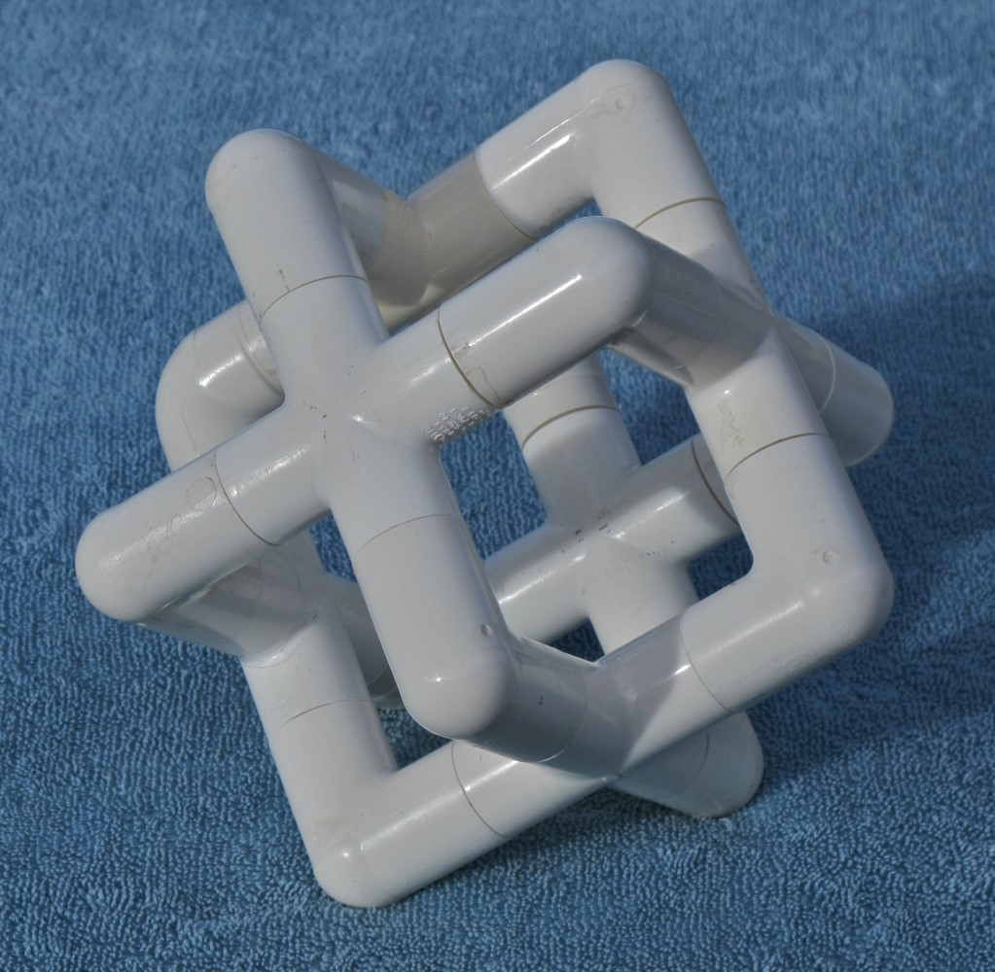
(a) (b) (c) (d)
Figure 2: Orientable handle-bodies made from PVC pipe components: (a) simple torus of genus 1,
(b) 2-hole torus of genus 2, (c) handle-body of genus 3, (d) handle-body of genus 7.
Tables are mostly treated just like figures, except that the Figure Caption is placed above the table body, and that it starts with the string “Table 1: ”. All figures and tables must be referenced and explained in the main text, and they must not bleed into the margins.

Table 1: Number of Topologically Different Linkings of Two Cube-Frames.

 | 2 edge-loops | 3 edge-loops | 4 edge-loops | 5 edge-loops | 6 edge-loops
2 edge-loops | 2sm, 1dm |  |  |  |  | 3
3 edge-loops | 0 | 1sm, 1sp  2sc, 2dm |  |  |  | 6
4 edge-loops | 0 | 2dc | 1sm, 10sc  2dm, 10dc |  |  | 25
5 edge-loops | 0 | 0 | 1dm, 20dc | 16sc, 3dm  1dp, 24dc |  | 65
6 edge-loops | 0 | 0 | 3dm, 2dc | 26dc | 14sc | 45
 |  |  |  |  | total: | 144
 | s: swap symmetry |  | m: mirror symmetry
 | d: different roles |  | c: chiral configuration |  | date: | 1/20/2016
 | for the two frames |  | p: pseudo chirality

Sections and Subsections
Important words should be capitalized in your paper’s title and section headings, while conjunctions (e.g., “and” / “or”) and prepositions (e.g., “of” / “with”) begin with a lower case letter. Avoid most punctuation (one colon or comma is acceptable). Do not end a title or section heading with a period. For section headings use the style Heading 1. Do not use numbered sections unless you refer to a section by number rather than title in the text. If you must have your sections numbered use the style Heading Numbered 1. For any 8-page Bridges paper, it would probably be excessive to use more than two levels of hierarchy in your document. In all papers the Abstract, Acknowledgments, and References headings are unnumbered sections.

Subsections
If needed, you may introduce subsections using the style Heading 2. Subsections are never numbered.

Vertical Spacing and Page Breaks
The various styles for headings and paragraphs come with their own built-in vertical spacing. By default they should result in a good-looking layout. But occasionally it is necessary to change vertical spacing a little in order to avoid inconvenient page breaks. Try to avoid the last line of a paragraph appearing at the beginning of the next page and don’t leave a section title on a separate page from what follows. Feel free to introduce an extra line of empty text, or to insert a Blank_line to improve layout.

Wrap-up
The paper should end with a brief section that provides some Summary and Conclusions. This may be followed by Acknowledgments (optional) and References. Only list references that you cite in your paper. List all references alphabetically by last name of first author and number them sequentially; style Reference will do this for you. When citing references in the text, type the corresponding number in square brackets and use a reference like: “see Coxeter [1]” or just insert “[1]” after the corresponding quote. For more than one reference use [1][2]. See the references for correct article [1], book [3], and Bridges Conference Proceedings [5] citations. Examples and templates for other types of references can be found in the Guidelines for References section of the Paper Formatting webpage. Don’t insert links to references in the body of the paper.

Writing Style and Final Format
There is no need to use only the passive voice, often encountered in some formal academic journals. It is perfectly acceptable to use the first person “I” when talking about your own artistic endeavors, and the inclusive, academic “we” works well for more formal statements.
To submit your paper via EasyChair [2], you will have to convert it into a PDF (Portable Document Format) file and that file must not exceed 10 MB. Papers will appear in the online Bridges Archives and in print in full color.

Summary and Conclusions
Please adhere to the style incorporated in this template. Substantive deviations from this style are grounds for rejecting your paper without any detailed review.

Acknowledgements
Suggestions on how the clarity and usefulness of this guide could be enhanced would be gladly accepted.

References
- H. S. M. Coxeter. “The Non-Euclidean Symmetry of Escher’s Picture Circle Limit III.” Leonardo, vol. 12, no. 1, 1979, pp. 19–25.
- EasyChair. Log in page. https://easychair.org/account/signin.cgi.
- G. W. Hart and H. Picciotto. Zome Geometry: Hands-on Learning with Zome Models. Key Curriculum Press, 2001.
- OpenOffice. https://www.openoffice.org.
- C. H. Séquin. “From Klein Bottles to Modular Super-Bottles.” Bridges Conference Proceedings, Jyväskylä, Finland, Aug. 9–13, 2016, pp. 41–48. http://archive.bridgesmathart.org/2016/bridges2016-41.html.

